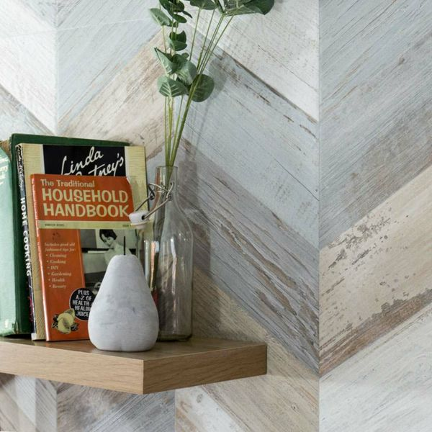**BoCoCa Urban Mix Chevron**

**Wood Tiles:**

## **Product Description**

If your bathroom, kitchen or living area is in desperate need of a refresh, create a characterful statement floor with these Urban Mix Chevron Wood Tiles. They have a striking chevron design, with a mix of white, grey and brown hues. These floor tiles have a wood effect design with an aged, faded painted effect; perfect for introducing character into any room throughout the house. They're made from durable porcelain and have a matt finish. For a closer look, order a sample.

## **Product Info**

* Product ID: 15659
* Tiles Per SQM: 2.4691358024691
* Sale by: Per SQM
* Size: 450x900x9mm
* Weight: 9.98 KG
* Material Type: Porcelain
* Finish: Matt
* Colour: Brown
* Suitability: Floors, Walls
* Grade: 4
* Rectified Edge: No
* Underfloor Heating: Yes
* Thickness (mm): 9